**Statistical Analysis Of The Average Salaries Of Employees At Acorn Ltd Using Correlation And One Way ANOVA**

Rodney M Kimathi

This study aims to develop a statistical model to predict how education levels influence how employees were compensated at Acorn ltd, a mid-sized construction company. The tests that were used were Kendall’s tau-b correlation coefficient and Analysis of Variance (ANOVA). All statistical analysis was carried out using IBM SPSS.

**Hypotheses**

The following hypotheses were proposed:

* H0: µsalary14 = µsalary17 = µsalary18

The average salaries for education levels 14, 17 and 18 are equal.

* H1: µsalary14≠ µsalary17 ≠ µsalary18

The average salaries for education levels 14, 17 and 18 are not equal.

**DESCRIPTIVE STATISTICS**

The results show that the dataset has 474 cases (N=474).

Mean salary of all employees is $34,419.57 (M=$34,419.57)

The standard Deviation of employee salary is $17,075.661 ($SD=17, 075.661).

|  |  |  |  |  |  |
| --- | --- | --- | --- | --- | --- |
| **Table 1**  *Descriptive statistics for salary* | | | | | |
|  | N | Minimum | Maximum | Mean | Std. Deviation |
|  |  |  |  |  |  |
|  |  |  |  |  |  |
| Current Salary | 474 | $15,750 | $135,000 | $34,419.57 | $17,075.661 |
| Valid N (listwise) | 474 |  |  |  |  |
|  |  |  |  |  |  |

**Table 2**

*Descriptive statistics for salary*

|  |  |  |  |  |
| --- | --- | --- | --- | --- |
|  | | | | |
|  | | | Statistic | Std. Error |
| Current Salary | Mean | | $34,419.57 | $784.311 |
| 95% Confidence Interval for Mean | Lower Bound | $32,878.40 |  |
| Upper Bound | $35,960.73 |  |
| 5% Trimmed Mean | | $32,455.19 |  |
| Median | | $28,875.00 |  |
| Variance | | 291578214.453 |  |
| Std. Deviation | | $17,075.661 |  |
| Minimum | | $15,750 |  |
| Maximum | | $135,000 |  |
| Range | | $119,250 |  |
| Interquartile Range | | $13,163 |  |
| Skewness | | 2.125 | .112 |
| Kurtosis | | 5.378 | .224 |

The table shows the various education levels.

**Table 3**

*Frequency Table for education level*

|  |  |  |  |  |  |
| --- | --- | --- | --- | --- | --- |
|  | | | | | |
|  | | Frequency | Percent | Valid Percent | Cumulative Percent |
|  | |  |  |  |  |
| Valid | 8 | 53 | 11.2 | 11.2 | 11.2 |
| 12 | 190 | 40.1 | 40.1 | 51.3 |
| 14 | 6 | 1.3 | 1.3 | 52.5 |
| 15 | 116 | 24.5 | 24.5 | 77.0 |
| 16 | 59 | 12.4 | 12.4 | 89.5 |
| 17 | 11 | 2.3 | 2.3 | 91.8 |
| 18 | 9 | 1.9 | 1.9 | 93.7 |
| 19 | 27 | 5.7 | 5.7 | 99.4 |
| 20 | 2 | .4 | .4 | 99.8 |
| 21 | 1 | .2 | .2 | 100.0 |
| Total | 474 | 100.0 | 100.0 |  |

The boxplot below shows the range of salaries.

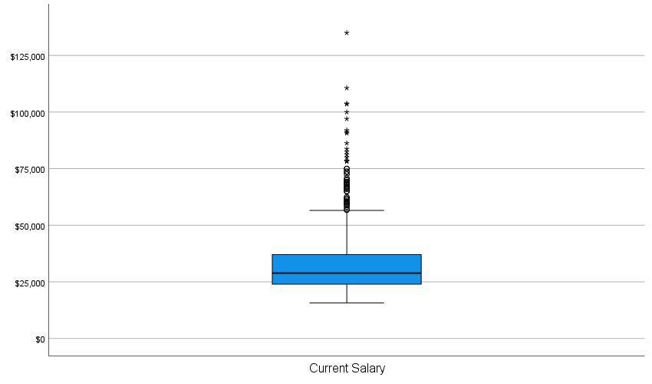

|  |  |
| --- | --- |
|  |  |

**CORRELATION TEST**

A Kendall’s Tau correlation test with α=.05 was conducted to measure the strength and the direction of the association between education level and current salary. The result revealed a positively strong significant relationship*. (r=.554, p<.001).*

**Table 4**

|  |  |  |  |  |
| --- | --- | --- | --- | --- |
| *Correlation table* | | | | |
|  | | | Current Salary | Educational Level (years) |
| Kendall's tau_b | Current Salary | Correlation Coefficient | 1.000 | .554** |
| Sig. (2-tailed) | . | .000 |
| N | 474 | 474 |
| Educational Level (years) | Correlation Coefficient | .554** | 1.000 |
| Sig. (2-tailed) | .000 | . |
| N | 474 | 474 |

**ANALYSIS OF VARIANCE (ANOVA TEST)**

Analysis of variance for salary between different job categories was conducted. We used education levels 14, 17 and 18 for the analysis.

Descriptives table shows different salary means for employees in education levels 14, 17 and 18.

**Table 5**

|  |  |  |  |  |  |  |  |  |
| --- | --- | --- | --- | --- | --- | --- | --- | --- |
| *Mean, deviation and CI table* | | | | | | | | |
|  | | | | | | | | |
| Current Salary | | | | | | | | |
|  | N | Mean | Std. Deviation | Std. Error | 95% Confidence Interval for Mean | | Minimum | Maximum |
| Lower Bound | Upper Bound |
| 14 | 6 | $31,625.00 | $5,790.402 | $2,363.922 | $25,548.35 | $37,701.65 | $25,950 | $39,900 |
| 17 | 11 | $59,527.27 | $19,789.560 | $5,966.777 | $46,232.47 | $72,822.08 | $27,000 | $82,500 |
| 18 | 9 | $65,127.78 | $13,461.876 | $4,487.292 | $54,780.06 | $75,475.49 | $43,950 | $86,250 |
| Total | 26 | $55,026.92 | $19,960.579 | $3,914.592 | $46,964.67 | $63,089.18 | $25,950 | $86,250 |

To test for significance, a levenes’s test was conducted. The model satisfies the assumption of homogeneity of variance. (sig=.054).

**Table 6**

|  |  |  |  |  |  |  |  |  |  |  |  |
| --- | --- | --- | --- | --- | --- | --- | --- | --- | --- | --- | --- |
| *Tests of Homogeneity of Variances* | | | | | | | | | | | |
|  | | | | | | | | | | | |
|  | | | | Levene Statistic | | df1 | | df2 | | Sig. | |
| Current Salary | Based on Mean | | | 3.334 | | 2 | | 23 | | .054 | |
| Based on Median | | | 2.319 | | 2 | | 23 | | .121 | |
| Based on Median and with adjusted df | | | 2.319 | | 2 | | 16.375 | | .130 | |
| Based on trimmed mean | | | 3.171 | | 2 | | 23 | | .061 | |
|  |  | | |  | |  | |  | |  | |
| **Table 7**  *ANOVA* | | | | | | | | | | |
|  | | | | | | | | | | |
| Current Salary | | | | | | | | | | |
|  | | Sum of Squares | df | | Mean Square | | F | | Sig. | |
| Between Groups | | 4426930030.109 | 2 | | 2213465015.054 | | 9.200 | | .001 | |
| Within Groups | | 5533687373.737 | 23 | | 240595103.206 | |  | |  | |
| Total | | 9960617403.846 | 25 | |  | |  | |  | |

ANOVA table shows that the difference of salary means for the said employees is significant (Sig=.001).

**Table 8**

|  |  |  |  |  |  |  |  |
| --- | --- | --- | --- | --- | --- | --- | --- |
| *Multiple Comparisons Table* | | | | | | | |
|  | | | | | | | |
|  | (I) Educational Level (years) | (J) Educational Level (years) | Mean Difference (I-J) | Std. Error | Sig. | 95% Confidence Interval | |
|  | Lower Bound | Upper Bound |
| Tukey HSD | 14 | 17 | -$27,902.273* | $7,872.196 | .005 | -$47,616.90 | -$8,187.65 |
| 18 | -$33,502.778* | $8,175.082 | .001 | -$53,975.93 | -$13,029.62 |
| 17 | 14 | $27,902.273* | $7,872.196 | .005 | $8,187.65 | $47,616.90 |
| 18 | -$5,600.505 | $6,971.734 | .705 | -$23,060.07 | $11,859.06 |
| 18 | 14 | $33,502.778* | $8,175.082 | .001 | $13,029.62 | $53,975.93 |
| 17 | $5,600.505 | $6,971.734 | .705 | -$11,859.06 | $23,060.07 |
| Games-Howell | 14 | 17 | -$27,902.273* | $6,417.986 | .002 | -$44,888.55 | -$10,916.00 |
| 18 | -$33,502.778* | $5,071.875 | .000 | -$47,093.01 | -$19,912.55 |
| 17 | 14 | $27,902.273* | $6,417.986 | .002 | $10,916.00 | $44,888.55 |
| 18 | -$5,600.505 | $7,465.803 | .737 | -$24,701.28 | $13,500.27 |
| 18 | 14 | $33,502.778* | $5,071.875 | .000 | $19,912.55 | $47,093.01 |
| 17 | $5,600.505 | $7,465.803 | .737 | -$13,500.27 | $24,701.28 |
|  | | | | | | | |

Multiple comparisons table shows that the significant difference is between education levels:

14 and 17: sig=.005

14 and 18: sig=.001

A one-way ANOVA was used to test for salary differences among three education levels. Salary differed significantly across the three education levels, **F (2, 23) = 9.2, p = .001**. Tukey HSD post-hoc comparisons of the three groups indicate that education level **14 (M = $31,625, 95% CI [$25,548.35, $37,701.65])** have significantly lower salary than the level 17**(M = $59,527.27, 95% CI [$46,232.47, $72,822.08]), p = .005** and level 18**(M = $65,127.7, 95% CI [$54,780.06,**

**$75,475.49]), p = .001**. We therefore reject the null hypothesis that average salary is equal among the education levels.